PROJECT DOCUMENTATION

AUTOMATED ATTENDANCE SYSTEM FOR RURAL SCHOOLS
USING FACE RECOGNITION

Academic Project Daily Log

Activity Summary -June 1 to June 30,2026

Day | Date | Activity | Status
Day 1 | June 1 | Project Title Finalization | Completed
Day 2 | June 2 | Requirement Gathering | Completed
Day 3 | June 3 | Objective Definition | Completed
Day 4 | June 4 | User and Module Identification | Completed
Day 5 | June 5 | User Case Diagram Preparation | Completed
Day 6 | June 6 | Database Requirement Analysis | Completed
Day 7 | June 7 | ER Diagram Design | Completed
Day 8 | June 8 | Database Schema Creation | Completed
Day 9 | June 9 | Login Module Development | Completed
Day 10 | June 10 | Dashboard Development | Completed
Day 11 | June 11 | Database Connectivity | Completed
Day 12 | June 12 | Student Registration Module | Completed
Day 13 | June 13 | Attendance Report Module | Completed
Day 14 | June 14 | Python Environment Setup | completed
Day 15 | June 15 | Face Image Capture Module | completed
Day 16 | June 16 | Face Detection | completed
Day 17 | June 17 | Model Training | completed
Day 18 | June 18 | Face Recognition Module | Completed
Day 19 | June 19 | Attendance Marking | Completed
Day 20 | June 20 | Automatic Absent Marking | Completed
Day 21 | June 21 | Attendance Report Enhancement | Completed
Day 22 | June 22 | Multiple Student Testing | Completed
Day 23 | June 23 | Dashboard Integration | Completed
Day 24 | June 24 | System Testing | Completed
Day 25 | June 25 | Bug Fixing | Completed
Day 26 | June 26 | System Validation | Completed
Day 27 | June 27 | Final Integration | Completed
Day 28 | June 28 | Documentation Preparation | Completed
Day 29 | June 29 | ppt preparation | Completed
Day 30 | June 30 | Final demo and submission | Completed

DAY 1 – PROJECT TITLE FINALIZATION
Objective
To identify a real-time problem and finalize the mini project title based on real-world requirements.

Activities Performed
- Discussed different project ideas suitable for rural school environment.
- Identified manual attendance problems in schools.
- Studied face recognition technology basics.
- Selected OpenCV-based attendance system idea.
- Finalized project title as
“Automated Attendance System for Rural Schools Using Face Recognition”
Outcome
- Project title finalized successfully.
- Problem domain selected.
- Project approved for development.

DAY 2 – REQUIREMENT GATHERING
Objective
To analyze system requirements for developing the attendance system.

Activities Performed
- Studied manual attendance system problems.
- Identified need for automation.
- Listed functional requirements:
  - Student Registration
  - Face Capture
  - Face Recognition
  - Attendance Marking
  - Report Generation
- Listed software requirements (PHP, MySQL, Python, OpenCV).
Outcome
- Requirement analysis completed.
- System requirements documented.

DAY 3 – SYSTEM ANALYSIS
Objective
To study existing system and design proposed system.

Activities Performed
- Studied manual attendance drawbacks.
- Defined proposed face recognition system.
- Designed system workflow.
- Identified system modules.
Outcome
- Existing and proposed system finalized.
- Workflow designed.

DAY 4 – MODULE IDENTIFICATION
Objective
To identify modules required for the system.

Activities Performed
- Divided system into modules:
  - Login Module
  - Dashboard Module
  - Student Registration Module
  - Face Capture Module
  - Face Recognition Module
  - Attendance Module
  - Report Module
Outcome
- System modules defined successfully.

DAY 5 – USE CASE DESIGN
Objective
To design system use case diagram.
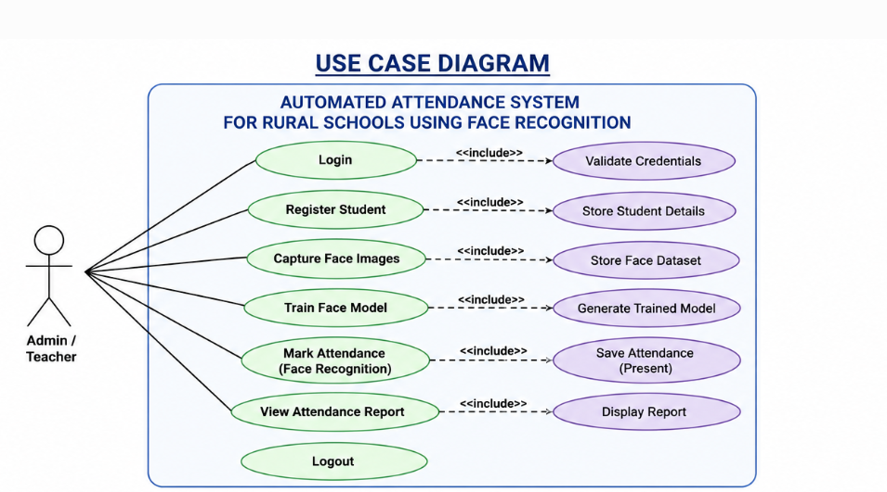
Activities Performed
- Identified actor: Admin/Teacher
- Identified use cases:
  - Login
  - Register Student
  - Capture Face
  - Train Model
  - Mark Attendance
  - View Report
- Created use case diagram.
Outcome
- Use case diagram completed.

DAY 6 – DATABASE DESIGN
Objective
To design database structure.
Activities Performed

- Designed MySQL database: attendance_db
- Created tables:
  - students
  - face_attendance
- Defined fields and relationships.
Outcome
- Database design completed.

DAY 7 – ER DIAGRAM
Objective
To design ER diagram for database.

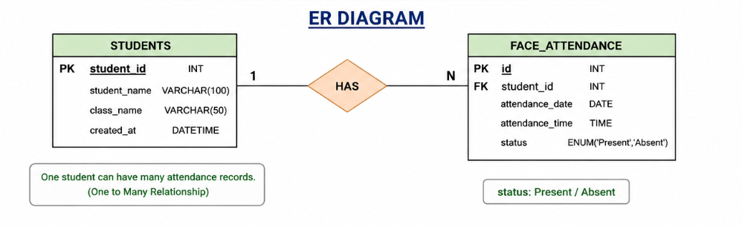
Activities Performed
- Identified entities:
  - Students
  - Attendance
- Defined relationship (1:N)
- Created ER diagram.
Outcome
- ER diagram completed successfully.

DAY 8 – DATABASE CREATION
Objective
To implement database in MySQL.

Activities Performed
- Created database in phpMyAdmin.
- Created tables:
  - students
  - face_attendance
- Tested database structure.
Outcome
- Database successfully created.

DAY 9 – LOGIN MODULE DEVELOPMENT
Objective
To develop secure login system.
Activities Performed

- Created login page using PHP & HTML.
- Added username/password validation.
- Connected login with MySQL database.
- Verified authentication process.
Outcome
- Login module working successfully.

DAY 10 – DASHBOARD DEVELOPMENT
Objective
To design main dashboard for system navigation.
Activities Performed

- Created dashboard UI.
- Added navigation links:
  - Student Registration
  - Mark Attendance
  - Reports
- Connected all modules.
Outcome
- Dashboard completed successfully.

DAY 11 – DATABASE CONNECTIVITY
Objective
To connect PHP application with MySQL database.

Activities Performed
- Created db.php file.
- Established connection using MySQLi.
- Tested connection with WAMP server.
- Verified student registration data storage.
- Ensured smooth communication between frontend and backend.
Outcome
- Database connection successfully established.

DAY 12 – STUDENT REGISTRATION MODULE
Objective
To develop student registration module.

Activities Performed
- Created registration form using HTML & PHP.
- Added fields: Student ID, Name, Class.
- Inserted data into MySQL database.
- Validated form inputs.
- Tested multiple student entries.
Outcome
- Student registration module working successfully.

DAY 13 – ATTENDANCE REPORT MODULE
Objective
To develop attendance report system.

Activities Performed
- Created report page using PHP.
- Fetched data from face_attendance table.
- Displayed student attendance records.
- Added table format UI.
- Verified present/absent data display.
Outcome
- Attendance report module completed.

DAY 14 – PYTHON ENVIRONMENT SETUP
Objective
To configure Python environment for face recognition.

Activities Performed
- Installed Python.
- Installed OpenCV library.
- Installed NumPy.
- Installed MySQL connector.
- Verified webcam functionality.
- Created project directory structure.
Outcome
- Python environment successfully configured.

DAY 15 – FACE IMAGE CAPTURE MODULE
Objective
To capture student face images for dataset creation.

Activities Performed
- Developed capture.py.
- Used OpenCV webcam capture.
- Detected face using Haar Cascade.
- Captured multiple images per student.
- Stored images in dataset folder.
Outcome
- Dataset created successfully for training.

DAY 16 – FACE DETECTION
Objective
To detect faces using OpenCV.

Activities Performed
- Implemented Haar Cascade classifier.
- Detected face from live webcam.
- Drew rectangle around face.
- Tested under different lighting conditions.
Outcome
- Face detection working successfully.

DAY 17 – MODEL TRAINING (LBPH)
Objective
To train face recognition model.

Activities Performed
- Created train.py.
- Loaded dataset images.
- Assigned labels for each student.
- Used LBPH algorithm for training.
- Generated trainer.yml file.
- Saved label mapping using pickle.
Outcome
- Face recognition model trained successfully.

DAY 18 – FACE RECOGNITION MODULE
Objective
To recognize students using trained model.

Activities Performed
- Developed recognize.py.
- Loaded trained model.
- Compared live face with dataset.
- Displayed student name on screen.
- Showed “Unknown” for unregistered faces.
Outcome
- Face recognition working successfully.

DAY 19 – ATTENDANCE MARKING (PRESENT)
Objective
To mark attendance automatically for recognized students.

Activities Performed
- Connected recognition with MySQL database.
- Inserted attendance record automatically.
- Stored date and time.
- Avoided duplicate entries.
- Displayed confirmation message.
Outcome
- Present attendance marked successfully.

DAY 20 – AUTOMATIC ABSENT MARKING
Objective
To mark absent students automatically.

Activities Performed
- Compared registered students with recognized students.
- Identified absent students.
- Inserted “Absent” status into database.
- Generated complete attendance list.
Outcome
- Automatic absent marking implemented successfully.

DAY 21 – ATTENDANCE REPORT ENHANCEMENT
Objective
To improve and finalize attendance report module.

Activities Performed
- Enhanced attendance report UI.
- Displayed Present and Absent status clearly.
- Improved table formatting.
- Added date-wise filtering option.
Outcome
- Attendance report improved successfully.

DAY 22 – MULTIPLE STUDENT TESTING
Objective
To test system with multiple students.

Activities Performed
- Added multiple student faces to dataset.
- Trained model again using all images.
- Tested recognition with different students.
- Verified correct name detection.
Outcome
- Multiple student recognition successful.

DAY 23 – DASHBOARD INTEGRATION
Objective
To integrate all modules into dashboard.

Activities Performed
- Connected all pages to dashboard.
- Linked registration, attendance, report modules.
- Tested navigation flow.
Outcome
- Dashboard integration completed.

DAY 24 – SYSTEM TESTING
Objective
To test full system functionality.

Activities Performed
- Tested login system.
- Tested student registration.
- Tested face recognition.
- Tested attendance marking.
- Verified database updates.
Outcome
- System working properly.

DAY 25 – BUG FIXING
Objective
To fix errors in system.

Activities Performed
- Fixed database errors.
- Improved recognition accuracy.
- Fixed duplicate attendance issue.
- Corrected UI alignment issues.
Outcome
- System errors resolved successfully.

DAY 26 – SYSTEM VALIDATION
Objective
To validate complete system.

Activities Performed
- Checked all modules together.
- Verified login to report flow.
- Tested real-time recognition.
- Ensured correct attendance marking.
Outcome
- System fully validated.

DAY 27 – FINAL INTEGRATION
Objective
To combine all modules into final system.

Activities Performed
- Integrated PHP frontend with Python backend.
- Connected MySQL database.
- Ensured smooth workflow.
- Tested full system flow.
Outcome
- Final system integration completed.

DAY 28 – DOCUMENTATION PREPARATION
Objective
To prepare project documentation.

Activities Performed
- Wrote project report.
- Added diagrams (ER, Use Case, Flowchart).
- Added module descriptions.
- Prepared final report structure.
Outcome
- Documentation completed successfully.

DAY 29 – PRESENTATION PREPARATION
Objective
To prepare PPT and viva preparation.

Activities Performed
- Created PowerPoint slides.
- Added system screenshots.
- Practiced project explanation.
- Prepared viva answers.
Outcome
- Presentation ready for submission.

DAY 30 – FINAL DEMONSTRATION & SUBMISSION
Objective
To demonstrate and submit the final project.

Activities Performed
- Demonstrated login system.
- Demonstrated student registration.
- Demonstrated face capture system.
- Demonstrated face recognition.
- Demonstrated automatic present marking.
- Demonstrated automatic absent marking.
- Displayed attendance report.
Outcome
- Project successfully completed and submitted.
- System working as expected.

